Objective: Image 24 well plate with 20x objective using Phase contrast, GFP, and TxRed channels

Materials: Keyence Fluorescence microscope BZ-X700, 24-well plate (provided by Tanya)

* File location of BF, GFP, and TxRed .bzcfg files:
  + J:\Users\Tanya\Configuration Files\24 well configuration

Procedure: Acquire BF, GFP, TxRed

* Optimize settings file for BF and save [10min]
* Optimize settings file for GFP and save [10min]
* Optimize settings file for TxRed and save [10min]
* Load settings file BF & Capture BF images [60min]
* Load settings file for GFP & Capture GFP images [60min]
* Load settings file for TxREd & Capture TxRed images [60min]

1. Select Sample Holder

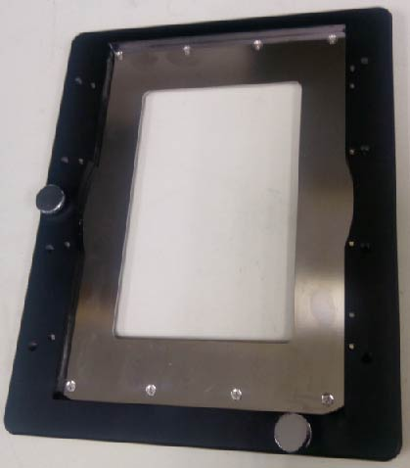

Figure 1. Sample Holder

1. Position 24-well plate

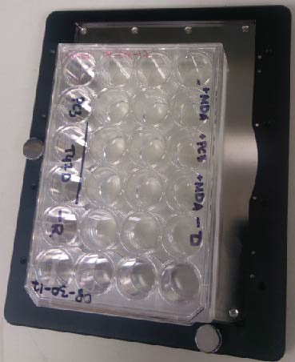

Figure 2. Plate orientation on plate holder. Align with bottom left corner.

1. Note on which wells will be imaged

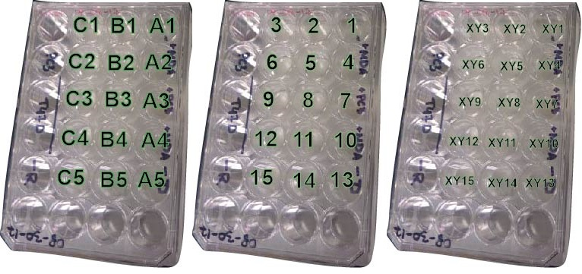

Figure 3. Wells imaged. Wells A1-C5 noted. Registered stitched areas 1-15 noted. Output folders XY1-15 noted.

1. Possible workaround to image a few more wells
   1. Rotate plate 180-degrees

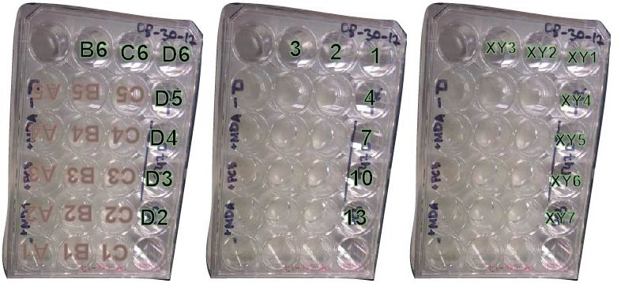

Figure 4. Additional wells imaged. Wells B6, C6, D2-D6 noted. Registered points modified 1,2,3,4,7,10,13. Output folders XY1, XY2, XY3, XY4, XY5, XY6, XY7.

1. Load plate

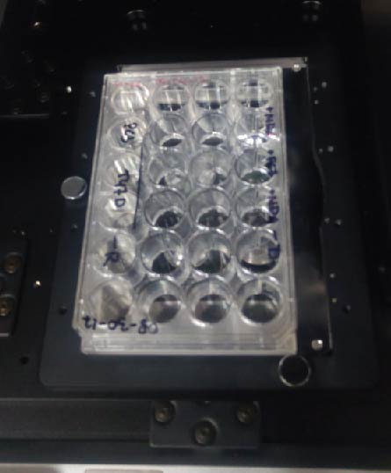

Figure 5. Plate loaded onto Keyence microscope.

1. Start BZ-X

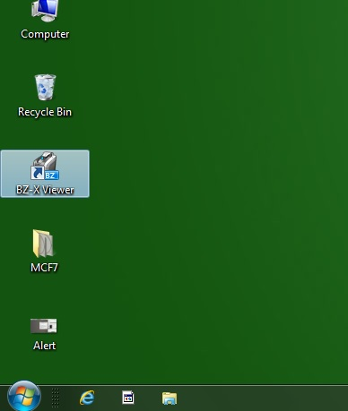

Figure 6. Desktop shortcut to BZx.

1. Login – click on Capture Still Images after login

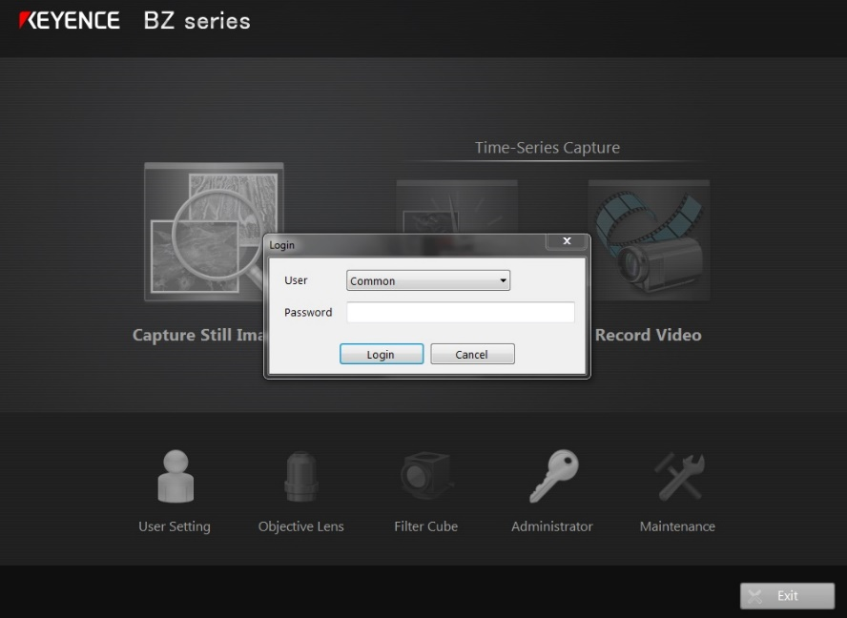

Figure 7. Login to Keyence BZ using common user – leave password blank.

1. Choose plate – it does not matter what you choose, since you will be loading a preset. Choose versatile (Wide).

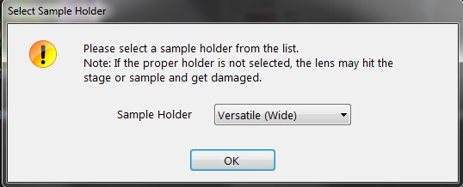

Figure 8. Select sample holder.

1. Load Capture Settings from file

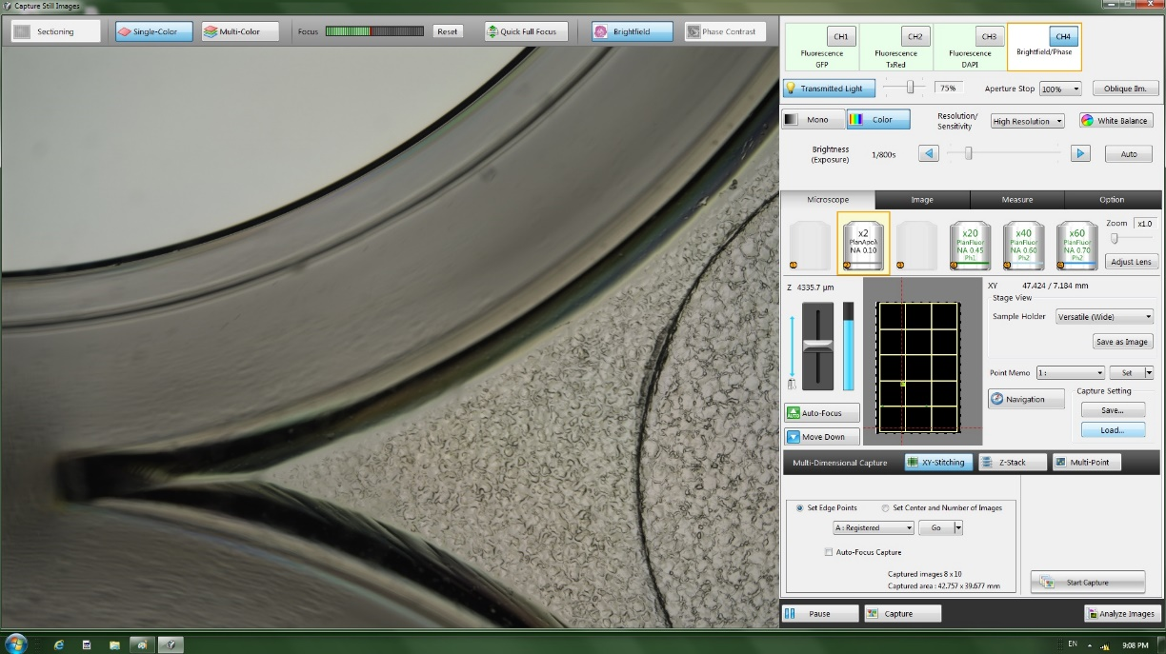

Figure 9. Load Capture settings.

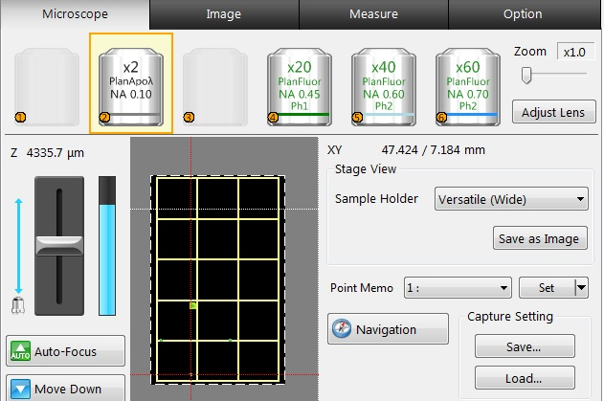

Figure 10. Load Capture Settings. Click load.

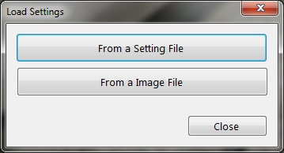

Figure 11. Load Capture Settings. Select From a Setting File.

1. Load .bzcfg file (one exists for each channel – there are three channels Phase Contrast (BF), GFP, TxRed

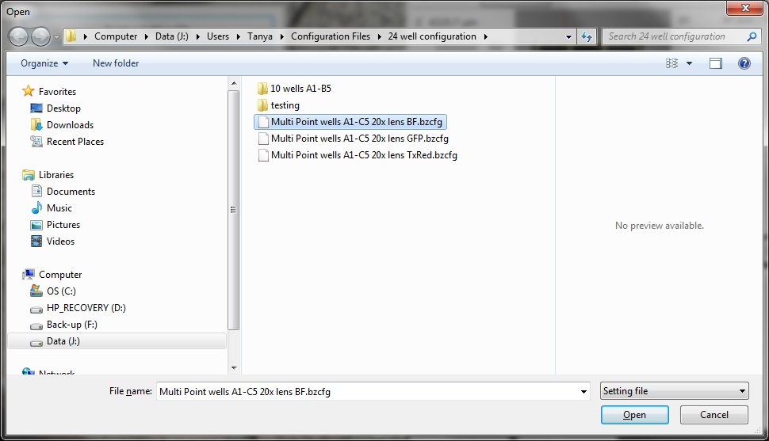

Figure 12. Load BZ configuration file. (.bzcfg ). Location of Tanya’s configuration files noted.

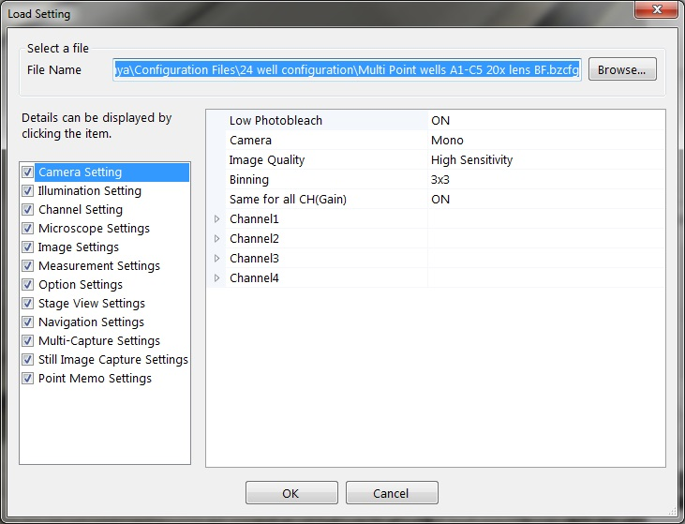

Figure 13. Load BZ configuration file (.bzcfg). Click OK.

1. BF configuration file loaded

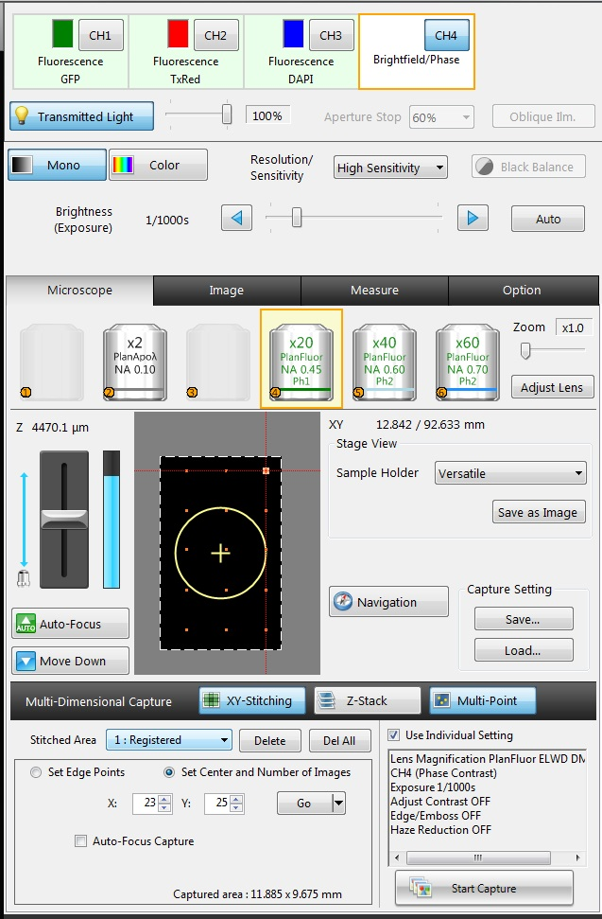

Figure 14. BZ configuration file loaded. Ensure settings are individually optimized for each well. Remember to click “set” for each stitched area – aka well, after optimizing the settings. Key settings to mind are: Transmitted light, the value is independent of interwell settings – it’s a global setting, in other words the setting is fixed once selected and throughout image acquisition; Resolution/Sensitivity; Brightness (Exposure); Z-focus.

1. Optimize individual well settings
   1. Resolution/Sensitivity = High Sensitivity
   2. Brightness/Exposure = [user determined]
      1. Make sure the level is appropriate for the entire well. Inspect how setting works in different areas of the well.
   3. Z-Focus (Z) = [user determined]
      1. Make sure the level is appropriate for the entire well. Inspect how setting works in different areas of the well.
   4. Stitched Area = 1-15
      1. Optimize brightness/exposure & Z-Focus for each stitched area
2. Inspect selected registered stitched area

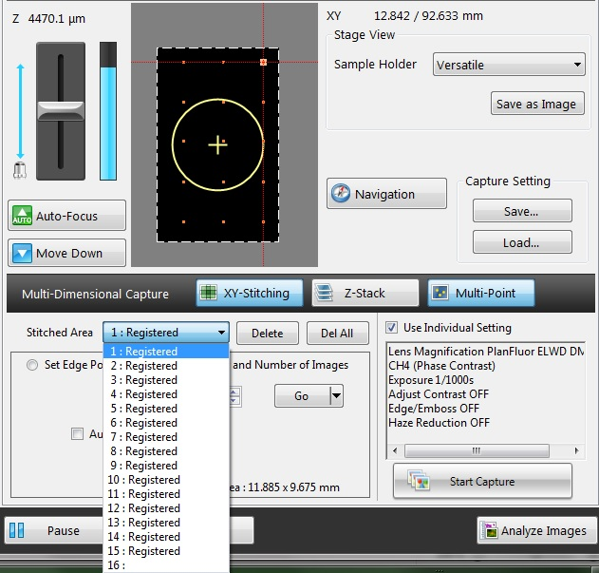

Example: choose 7 and click go

Figure 15. Navigating Registered Stitched Areas. When configuration file is loaded, stitched area #1 is selected and is in focus. Use the Stitched Area drop down menu to navigate to other stitched areas.

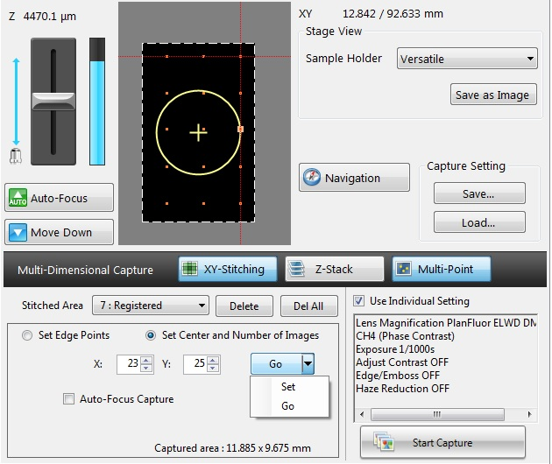

#7 selected

#1 in focus

Figure 16. Navigating Registered Stitched Areas. Stitched Area #7 is selected but not in focus. Click Go to focus on selected stitched area.

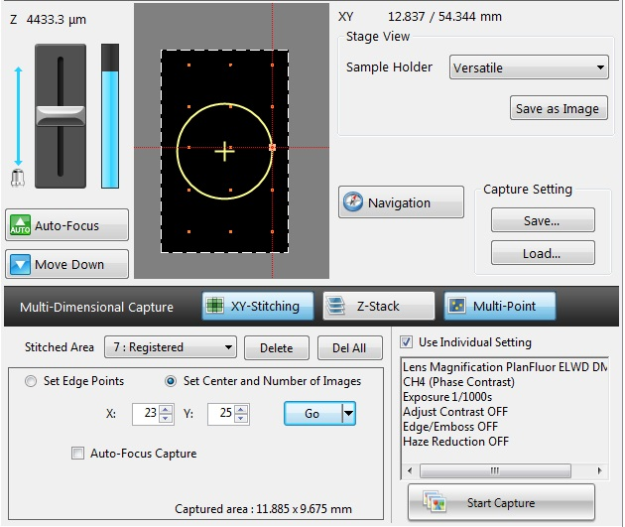

**Very Important:**

**Click “set” after optimizing settings for each well. Open drop down menu to see “set”.**

Figure 17. Navigating Registered Stitched Areas. Stitched Area #7 selected and in focus. Remember to “set” parameters for each well after optimizing.

1. Inspect well area from stage view

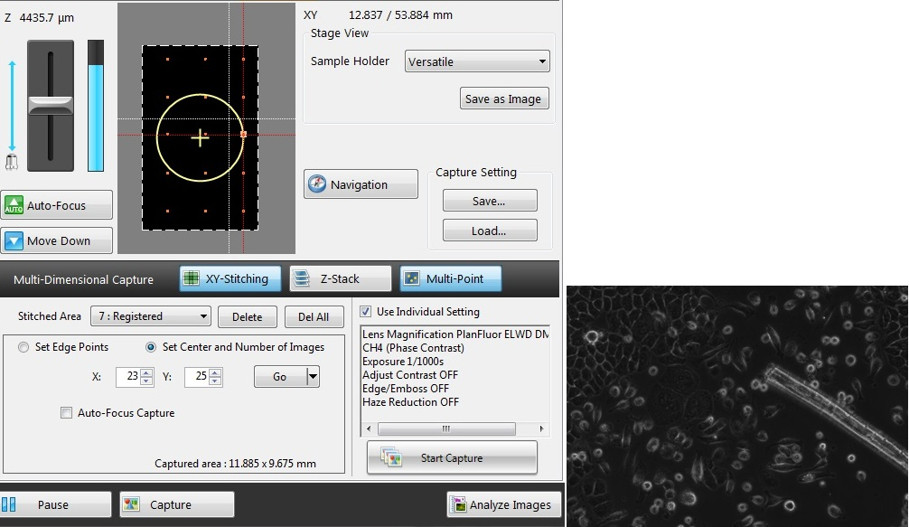

Figure 18. Inspecting inter well area. Validate the selected settings work for different areas of well. Sample image of well center with exposure set to 1/1000s.

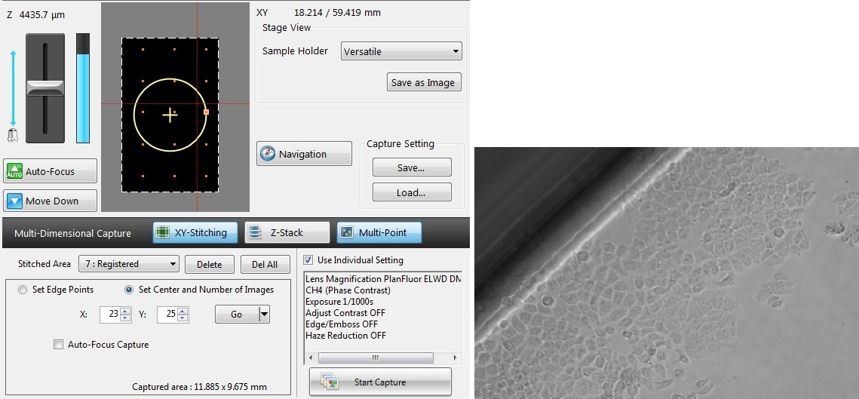

Click on grid to move stage

Figure 19. Inspecting inter well area. Validate the selected settings work for different areas of well. Sample image of well edge with exposure set to 1/1000s.

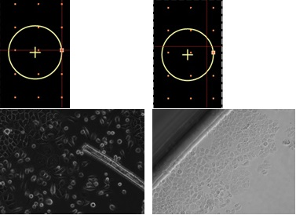

Figure 20. Inspecting inter well area. Stitched Area #7 selected and in focus. Inset left, well center in focus. Inset right, well wall in focus.

1. Using Navigation to inspect stitched area settings

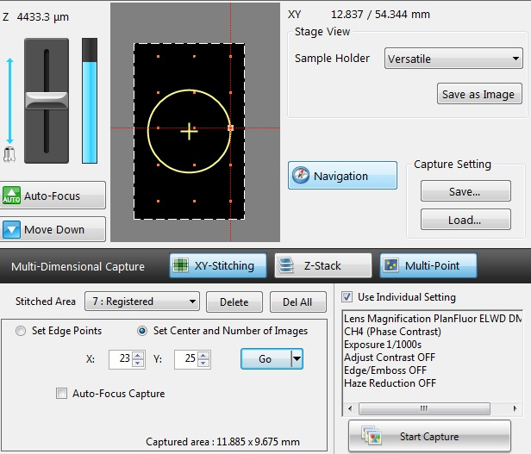

**Optimal well area is preset in config. file, but can be changed**

**Click “Navigation” to open navigation window.**

Figure 21. Stitched Area settings. Center set and number of images set. X=32, Y=25: number of tiled images in each axis direction to acquire centered to centroid. Captured area: 11.885x9.675 mm size of tiled area to be imaged. When opening navigation window, the current well in focus will be loaded. Due to program limitations, it is possible to have more stitched areas registered than navigable areas registered. Only 10 navigable areas can be registered, while there can be up to 30 stitched areas registered. Navigation is only used, here, to help position the well centroid and the resulting tiled image area. Be sure to set the registered area if trying to reposition the well centroid.

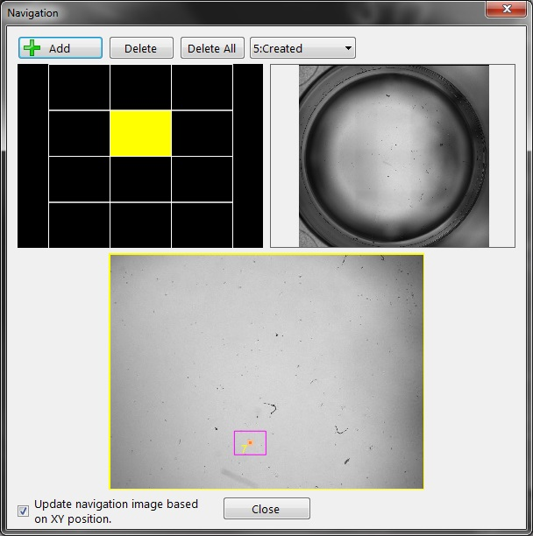

**Click in this window to reposition well center. Allows for fine adjustment**

Figure 22. Open Navigation Window. Inset top-left, is a grid of 4x3 images (2x) tiled together, which coverer an entire well from a 24-well plate. Inset top-right, stitched image of well. Inset bottom, current tile from 4x3 grid in selected. To fine tune precise location of well centroid, use clickable navigation window to shift well centroid. Click “Add” to overwrite existing position. The pink box indicated by red arrow, is the current area In focus. The pink dot and the number 7 inside the pink box indicate the exact position of registered area #7 centroid.

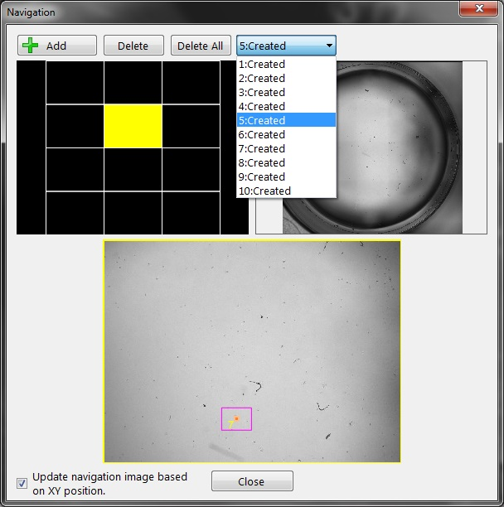

Figure 23. Open Navigation Window. Click “#:Created” drop down menu to navigate to another saved navigation area. Only 10 navigation areas can be saved at an instance. When creating navigation areas for a 24-well plate the 2x objective was selected and a 4x3 image grid was sufficient for capturing an entire well.

1. Validate stitched area aligns with well area

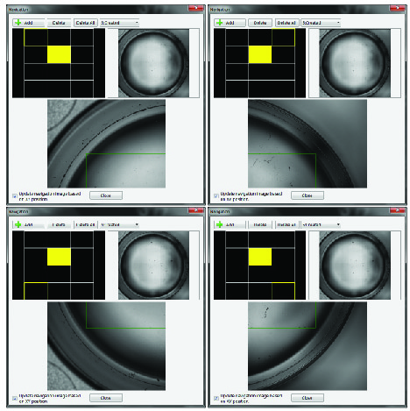

**Click on the grid to inspect capture area bounding box**

Figure 24. Open Navigation Window. Use the navigation window (4x3 grid) to verify location of the stitched area tile area, which has its boundaries indicated by a green rectangle.

1. Modifying stitched area and inspecting

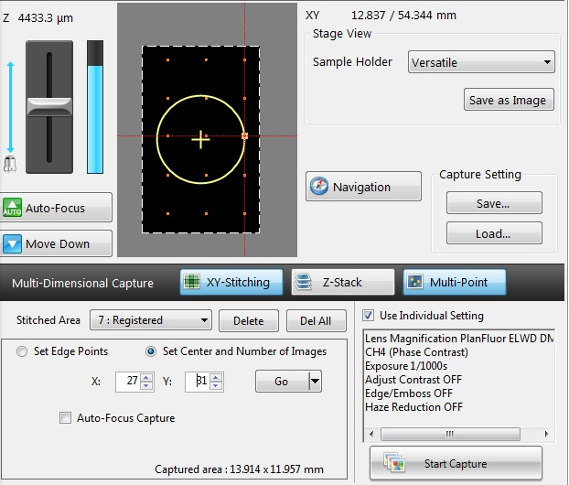

Figure 25. Modifying the stitched area. Increase the X tiles from 23 to 27 and Y tiles from 25 to 31.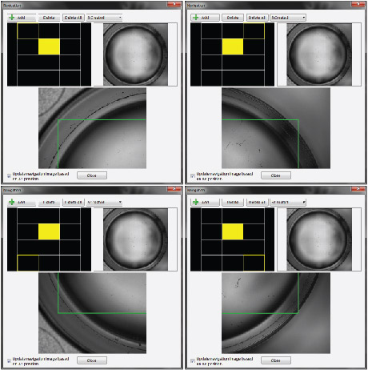

Figure 26. Modifying the stitched area. Open the “Navigation” window to observe the increase stitched area tile area, which has its boundaries indicated by the green rectangle.

1. Deleting registered stitched areas

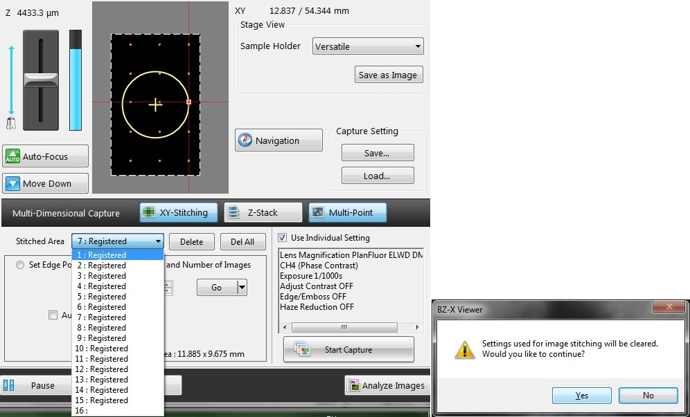

Figure 27. Delete Stitched area(s). Select desired stitched area and click “Delete”. Use to customize which wells are imaged.

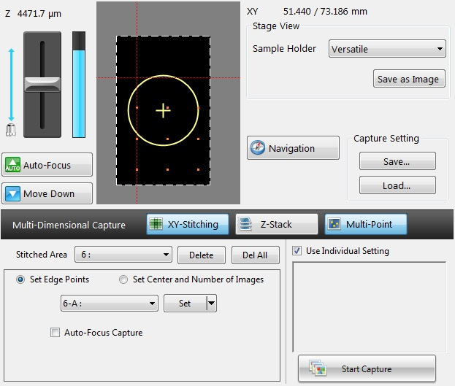

Figure 28. Delete Stitched areas.

1. Save configuration file – new or modified

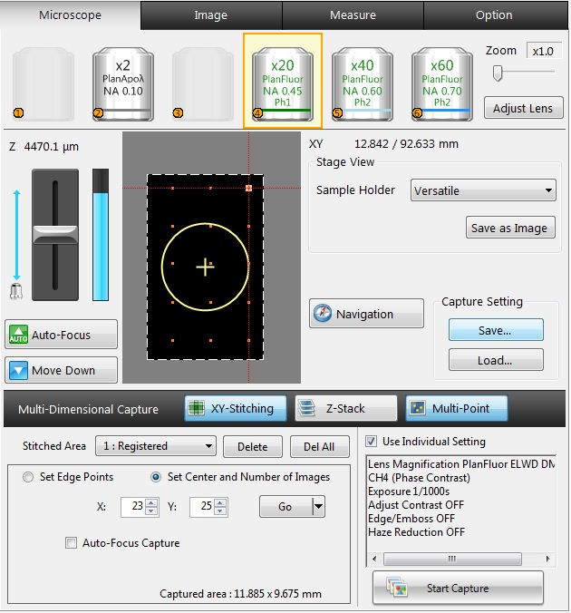

Figure 29. Save configuration file.

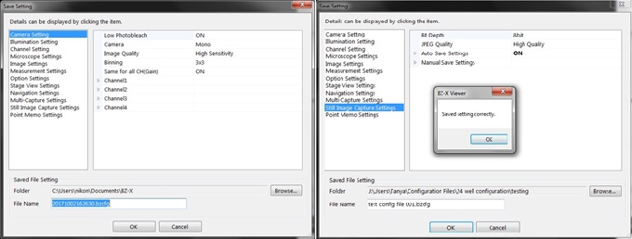

Figure 30. Save configuration file.

1. Start capture images

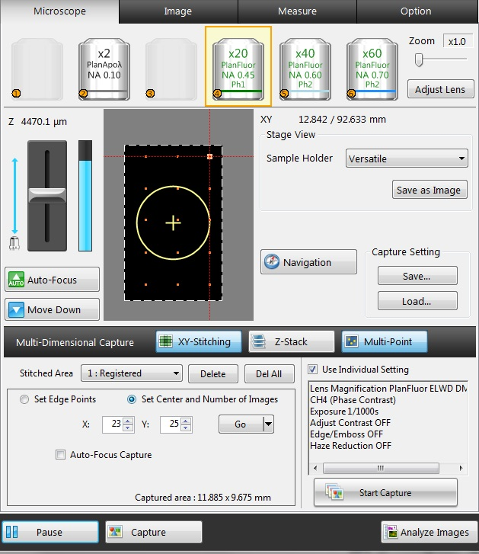

Figure 31. Start Capture.

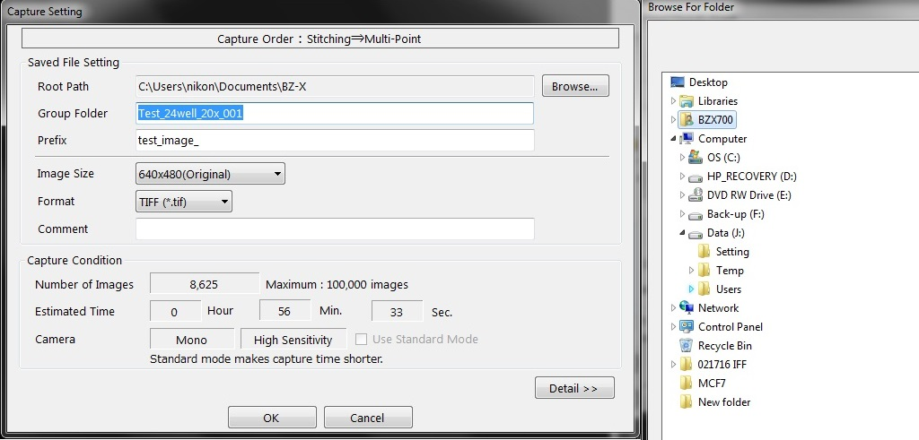

Figure 32. Start Capture Destination.

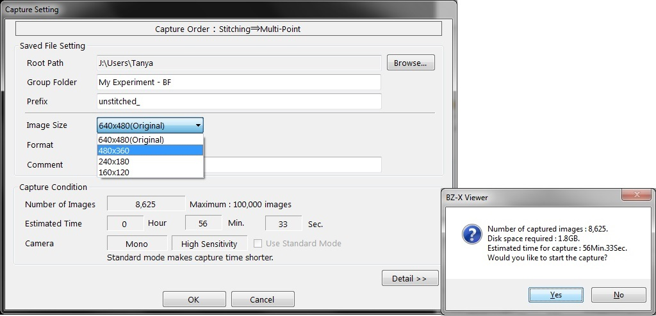

Figure 33. Start Capture. Settings.

1. Open BZx analyzer

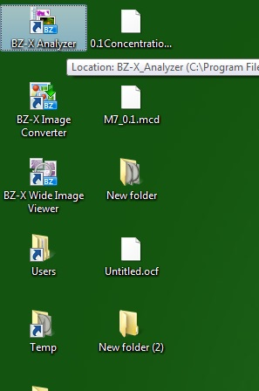

Figure 34. Open BZx analyzer.

1. Load Group – stitched images

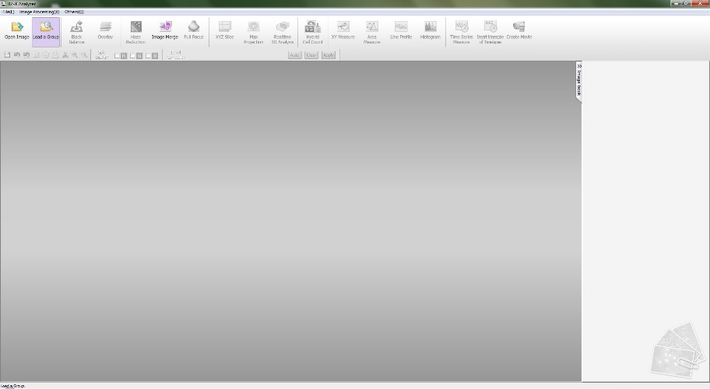

Figure 35. Select Load Group option.

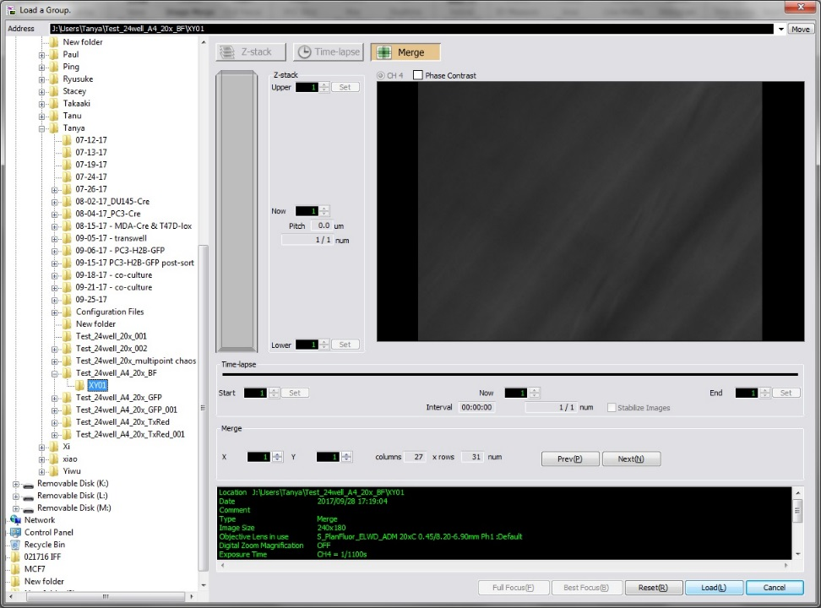

Figure 36. Load after selection.

1. Start Stitching

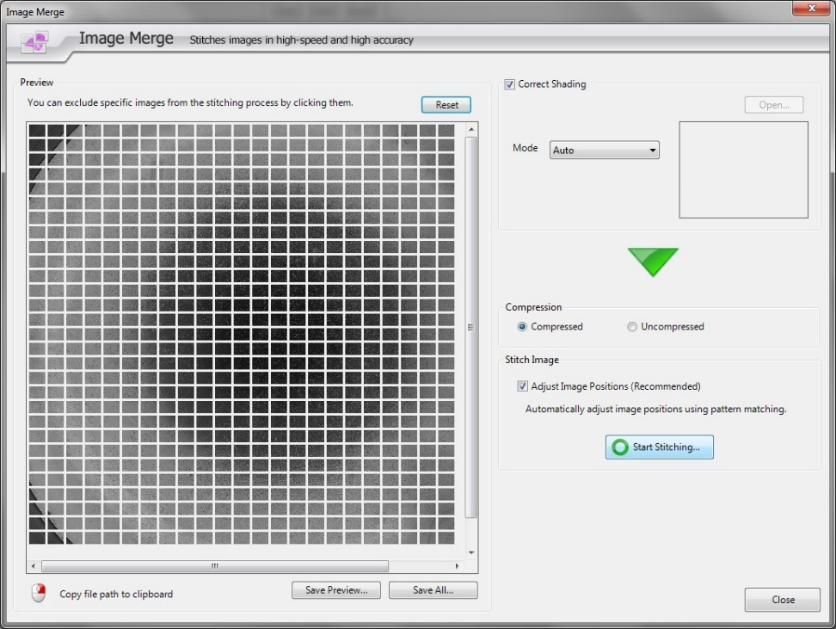

Figure 37. Start Stitching.

1. Inspect and Save wide image viewer file

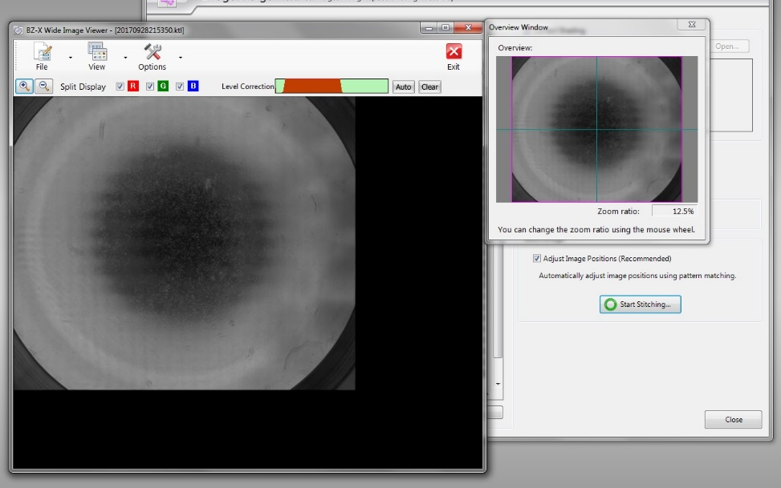

Figure 38. Navigate stitched images.

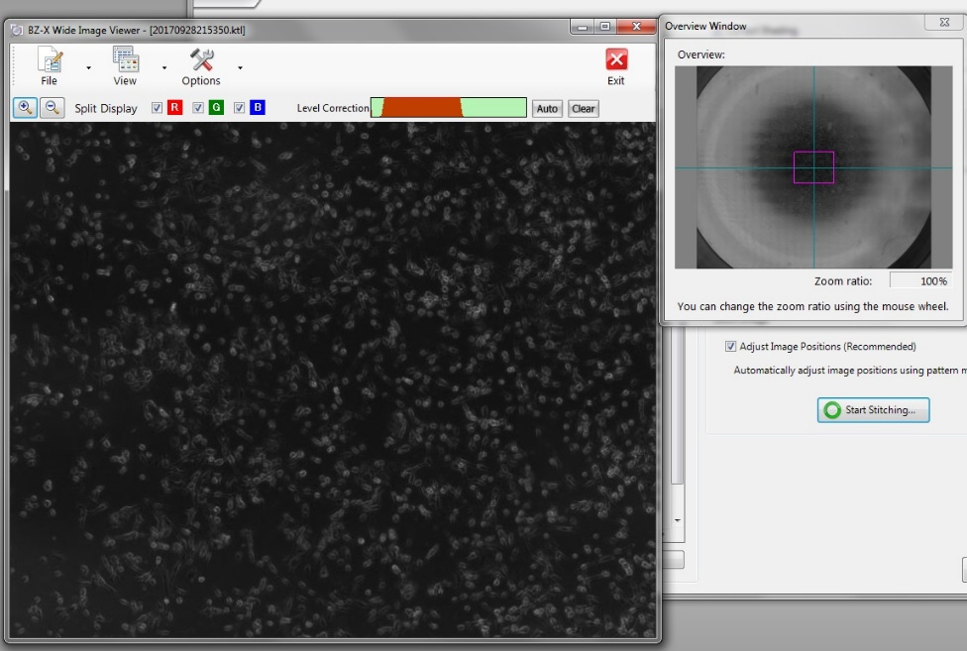

Figure 39. Navigate Stitched images.

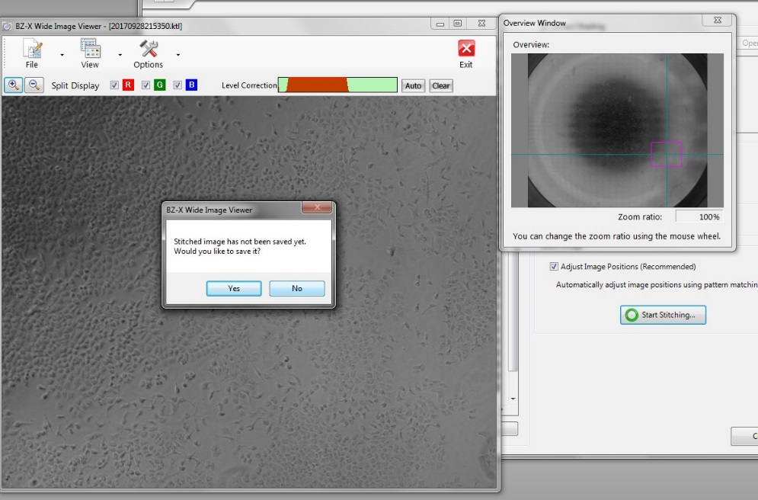

Figure 40. Save BZ stitched image file.

1. Close stitch window

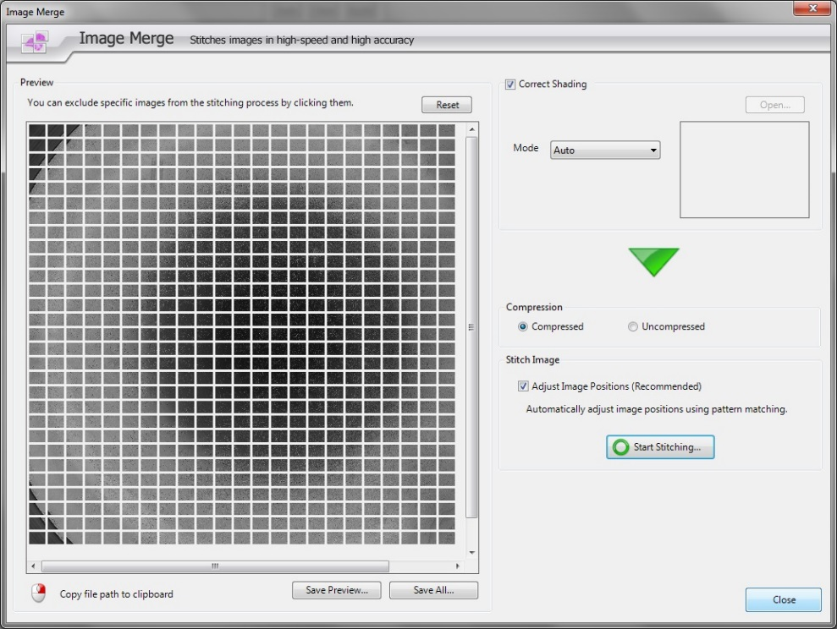

Figure 41. Close Stitching window.

1. Save merged Tif file

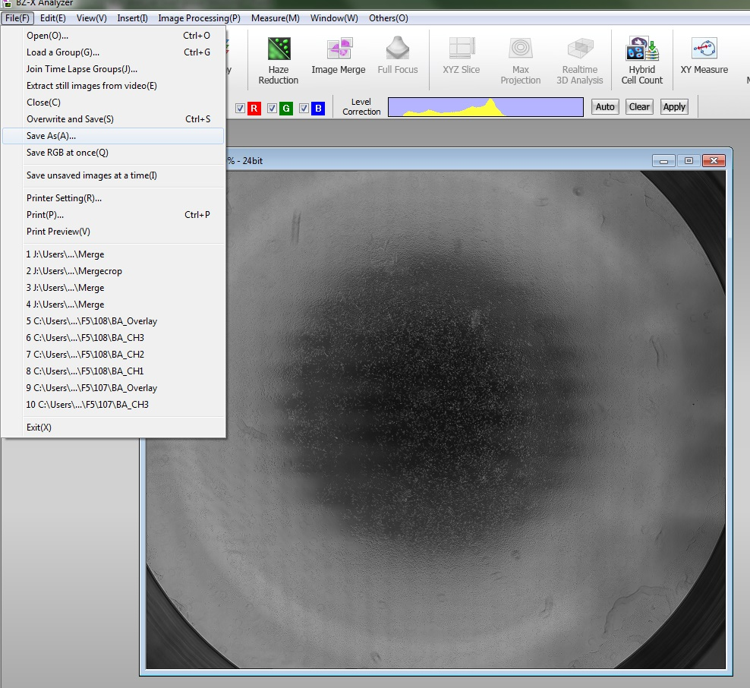

Figure 42. Save stitched image as tif or jpeg.

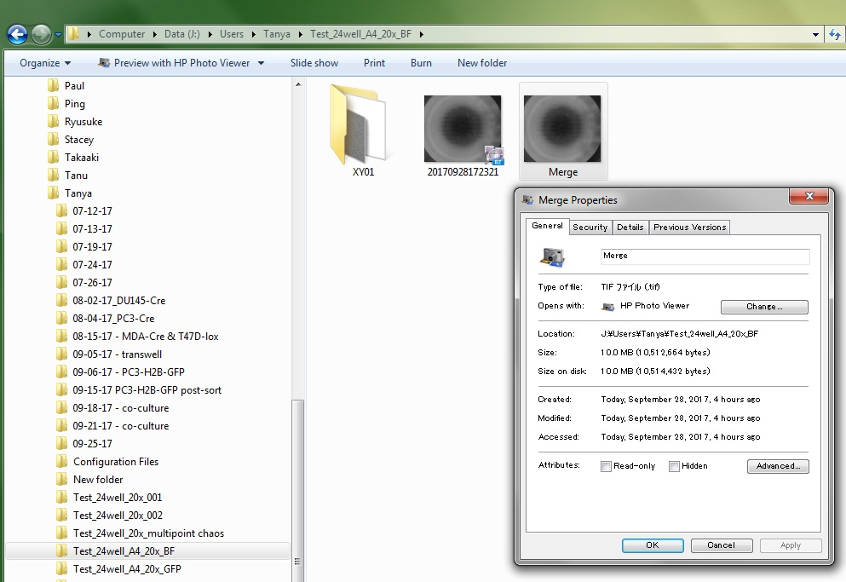

Figure 43. Two stitched files, 1-BZ stitched image, 2-tif or jpeg stitched image.